***Module – 04***

**Life Cycle Costing (LCC)**

Life cycle costing (LCC) belongs to the group of sustainability tools that focus on flows in connection with the production and consumption of goods and services. They focus on evaluating different flows in relation to various products or services instead of for example regions or nations. LCC is an economic approach that sums up the “total costs of a product, process or activity discounted over its lifetime”. It is associated with all costs occurring from purchase to disposal and can include the costs of externalities (the environmental costs). The idea is that the purchase price often does not reflect the full costs caused by a product over its whole life cycle and hence is not a sufficient indication.

**Types of LCC**

1. **The conventional LCC** is, to a large extent, the historic and current practice in many governments and firms, and is based on purely economic evaluation, considering various costs associated with a product that is born directly by a given actor; it is usually determined by the perspective of a single actor, often the product user. In this type of analysis, the external costs are often neglected. LCC is mainly applied as a decision-making tool, to support the acquisition of capital equipment and long-lasting products with high investment.
2. **Environmental LCC (eLCC)** summarizes all costs associated with the life cycle of a product that are directly covered by one, or more, of the actors involved in the product’s life cycle – for example, producers and consumers – including externalities that are anticipated to be internalized in the decision-relevant future. These costs must relate to real money flows. The eLCC is not a stand-alone technique but is seen as a [complementary analysis to the environmental life cycle assessment](https://www.lifecycleinitiative.org/wp-content/uploads/2012/12/2009%20-%20Guidelines%20for%20sLCA%20-%20EN.pdf).
3. **Societal LCC (sLCC)** includes monetarization of other externalities, including both environmental impacts and social impacts such as affected social well-being, job quality, etc. This focus makes it a suitable tool for decision-making at the societal level, including governments and policymakers.

**ELCC (Environmental Life Cycle Cost)**

Environmental Life Cycle Costing, opposite to traditional LCC, introduces so called environmental cost in the aspect of analysis. They are environment usage economic cost, especially paid for the use of environment, ecological tax, expense of emissions control, expense of ecological products' commercial. The accumulation of all the costs (direct and indirect) related to the environmental usage and its impact is Environmental life cycle cost. Environmental Life Cycle Costing is defined as a sum of costs that are incurred at the time of designing, building, production, transport, usage of articles until the end stockpiling, market usage and reprocessing.

**Process of carrying out Environmental Life Cycle Cost**

1. **Defining aim and range of definition:** The broader range and definition of the study should be clearly mentioned, the ELCC of the entire process/ system of a product or organization is very difficult to understand and analyze. Hence the system boundaries shall be clearly mentioned, and the scope of the study clearly defined before the conduction of ELCC.

Example: A alternator, which is the part of an electric vehicle, can be used as a scope of the study for determination of ELCC of the product.

1. **The information gathering:** This step involves the gathering of required information for the analysis, the data collection can be in the form of a questionnaire, interview or accessing of company data on procurement and spending. The detailed inventory analysis shall be carried out for the same.
2. Interpretation and recognition of critical points: After the data is received, the analysis is to be carried out to recognize all the critical parameters of the product and to arrive at logical conclusions.
3. **The sensitivity analysis:** The sensitivity analysis can involve understanding of the parameters of the study and trying to identify alternatives for the study to reduce the cost (environmental) of the product and bring out the sustainability from the process or the system.
4. **The summary:** The final interpretation of the results and providing logical background for the decision-making process and reinforcement of rules and regulation for the product process system.

**Activities to be performed for understanding the range of ELCC.**

1. Total cost determination from product and consumer side.
2. Product's evaluation of the competitiveness – determining consumer cost.
3. Reporting, monitoring and active cost determination inside companies.
4. Achieving agreement at manager level concerning product portfolio and their correlation with ELCC.
5. Possible alternatives identification.
6. Compromise identification between economic and environmental aspect.
7. Defining and determining the corporate social responsibility (CSR) together with social impact assessment.
8. Identifying potential company and long-term cost determination, analyzing potential economical consumer benefits at the EOL (end-of-life) influence on environment and public menace.
9. Defining relationship among individual criteria (internal cost compared to external cost).
10. Defining optimal life cycle concerning different changes e.g., Material purchase system.

**S-LCA (Social Life Cycle Assessment)**

Social Life Cycle Assessment (S-LCA) is a methodology to assess the social impacts of products and services4 across their life cycle (e.g. from extraction of raw material to the end-of-life phase, e.g. disposal). It offers a systematic assessment framework that combines quantitative as well as qualitative data. S-LCA provides information on social and socio-economic aspects for decision-making, in the prospect to improve the social performance of an organization5 and ultimately the well-being of stakeholders.

S-LCA is in large part based on the ISO 14040 framework for E-LCA. Therefore, it includes four phases: Goal and Scope, (Social) Life Cycle Inventory (S-LCI), (Social) Life Cycle Impact Assessment (S-LCIA) and Interpretation. It is an iterative methodology, which means that we can improve the assessment over time, going through several assessment loops.

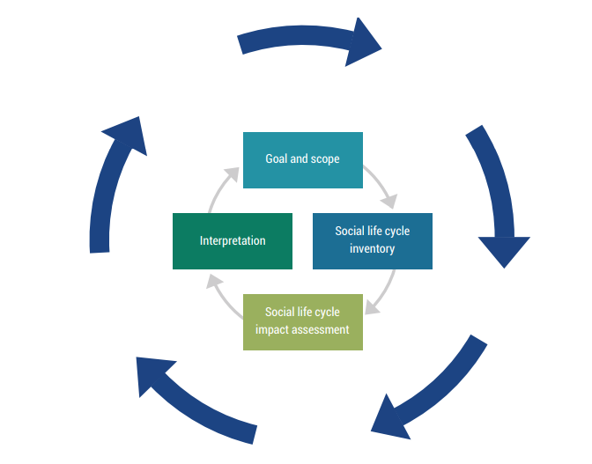

**Some Common Indicators of S-LCA in LCA**

1. Number/percentage of injuries, illnesses, and fatal accidents in the organization in the organization
2. Presence of formal policies on equal opportunities
3. Provision of fair wage or minimum wage as per the national wage policy or measurements.
4. The organization has infrastructure for fair and equal access of the stakeholders.
5. Imparting strength and training for stakeholders on policies and practices of the organization.
6. The employment is not conditioned by any restrictions.
7. Workers voluntarily agree on the terms of employment.
8. Absence of underage child workers.
9. Policies/organizational efforts to reduce unpaid time spent by women and children.
10. Local mortality rates and disease burden attributable to the effect of the product use or manufacturing.

**S-LCA impact categories**

| **Worker** | **Local Community** | **Value chain actors** | **Consumers** | **Society** | **Children** |
| --- | --- | --- | --- | --- | --- |
| 1. Freedom of association and collective bargaining 2. Child labor 3. Fair salary 4. Working hour 5. Forced labor. 6. Equal opportunities/ discrimination 7. Health and Safety 8. Social benefits/ Social security 9. Employment relationship 10. Sexual; harassment | 1. Access to material resources 2. Delocalization and migration 3. Cultural heritage 4. Respect to indigenous rights 5. Community engagement 6. Secure living conditions | 1. Fair competition 2. Promoting social responsibility 3. Supplier relationship 4. Wealth distribution | 1. Feedback 2. Transparency 3. End of cycle responsibility | 1. Public commitments 2. Prevention and mitigation of armed conflicts 3. Poverty alleviation 4. Corruption 5. Ethical treatment of animals | 1. Education to all 2. Health issues for children as consumers 3. Children concerns regarding marketing practices |

**Benefits of S-LCA**

1. Support companies in building a targeted strategy for future development of social policies.
2. Support decision-making processes that involve a variety of stakeholders with different knowledge and background.
3. Manage social risks with the identification of social hotspots.
4. Provide structure, credibility, and consistency to supply chain materiality assessment.
5. Support the disclosure of non-financial information.
6. Stimulates innovation in enterprises.
7. Decision makers to choose sustainable technologies and products.
8. Provides a framework to understand and analyse the social impacts of an organization or business.
9. Forces enterprises to become more responsible and take account of the stakeholders.
10. Helps identify weak links and hotspots in the product life cycle.

**Case Example of ELCC and SLCA in Eco-labelled Notebook Computer**

**Step 01: Goals and Scope:** The goals of the investigation were to apply the UNEP/ SETAC guidelines for conducting an S-LCA on a complex case, to identify social and environmental hot spots in the life cycle of the computer and to derive recommendations at the enterprise as well as at the policy level in order to improve the sustainable performance of the notebook. The functional unit is 1 notebook. The system boundary of the (environmental) LCA was broader. In addition to main processes, it also included transport, energy production and packaging. The design process was not considered, and the informal recycling process could not be analysed because of lack of data.

**Step 02: Inventory Analysis:** The starting point for both inventories was the disassembly of the notebook. This revealed suppliers, production locations and beyond that, weight and other characteristics of the modules contained in the computer. Inventory parameters for the S-LCA were based on the UNEP/SETAC approach: five main stakeholder groups (workers, local communities, society, value chain actors and consumers), and 30 themes of interest (subcategories) (child labour, forced labour, access to material resources, corruption, etc.). 88 indicators (e.g. ages of workers, number of working hours, number of jobs created, etc.) to measure the status of the subcategories were determined

**Step 03: Impact Assessment:** The first assessment phase evaluated the performance of the specific enterprise/sector compared to performance reference points based on international standards and conventions. These reference points, coordinated with stakeholders during the project, defined desirable and undesirable indicator values and therefore defined the benchmark applied in the impact and performance assessment. The second assessment phase considered the impacts which result from the enterprise/sector performance on the six impact categories related to working conditions, health and safety, human rights, indigenous rights (including cultural heritage), socio-economic repercussions and governance.

**Step 04: Interpretation:** First, the study demonstrated that the consideration of social and environmental aspects in parallel and for a complex product life cycle is possible. Second, the investigation showed that it is necessary to consider both social and environmental impacts to better understand the sustainable performance of a product. Both LCAs provide reasonable results, despite different perspectives and despite methodological challenges due to the novelty of the S-LCA approach and data gaps. Social hot spots were found in every stage of the product life cycle. In particular, informal activities in the mining and the recycling sector were found to cause serious social problems – not only for workers but also for local communities and the society. Beyond that, the production phase of the notebook computer was linked to poor enterprise performance and negative impacts, while the design phase and the formal recycling were in general uncritical.

**Carbon Footprint and Water Footprint**

* The carbon footprint measures the amount of greenhouse gases produced, measured carbon dioxide equivalents (in tonnes).
* The water footprint measures water use (in cubic metres per year).

|  | **Carbon Footprint** | **Water Footprint** |
| --- | --- | --- |
| **What is measured** | GHG emissions | Fresh water consumed or polluted |
| **Unit of**  **measurement** | Mass of CO2 per unit time | Water volume per unit of time |
| **Space and Time of measurement** | It is not necessary where and when the emissions occur. The emission units are inter-changeable (Kyoto Protocol) | It is important to understand where and when the WF occurs |
| **Footprint component** | CO2, CH4 , N2O, HFC, PFC, and SF6 | Blue, green, and grey WF |
| **Scope** | Direct and indirect emissions | Direct WF |
| **Sustainability of**  **the footprint** | For the planet, a maximum allowable GHG concentration needs to be estimated, which needs to be translated to a CF cap | Per catchment area, freshwater availability and waste assimilation capacity need to be estimated, which form a WF cap for the catchment. |
| **Method of**  **calculation** | Bottom to top approach | Top to bottom approach |
| **Entities for which the footprint can be accounted** | Processes, products, companies, industry sectors, individual consumers, groups of consumers, geographically delineated areas. | Processes, products, companies, industry sectors, individual consumers, groups of consumers, geographically delineated areas. |

**Applications of Life Cycle Assessment**

The applications of LCA is infinite and plenty, the LCA technique can be used and applied to all stages of life of a product/service/entity. The use of LCA varies from government establishments to individual levels.

1. **Government Level:** The governments use LCA tools to access the environmental situation of the country, this enables the policy makers to have a clear idea on the targets achieved to be achieved and pathways to reach those goals/ targets. The LCA enables policy makers to make clear decisions on the course of action to be taken for betterment of the society. Life cycle assessment tools shall also provide information about the harmful effects of any sector of the economy/industry/process. The government also uses LCA as a tool to levy taxes and penalties on the industries and organization causing environmental hazard. LCA can also used between countries to agree upon international pacts and policies for environmental protection and upliftment.
2. **Industries/Organizations:** The use of LCA is the most important for industries and organization as they are primary polluters of the environment. The life cycle assessment tools provides the organizations with data such as the environmental harm of a product/service, the cost of environmental protection and its pollution prevention, etc., such information is very crucial for the organizational management to review their management policies and principles for improvement of product/ service. The LCA is also used a tool to identify the hot spots in the process/system employed by the industry, this shows the specific point at which the environmental hazard has been created and thus enabling the organizations to take mitigative actions.
3. **Individuals:** At individual level, the LCA is used as a tool to make informed decisions on the products/ service consumed by them. The LCA provides insights into the positive and negative impacts of a product or service in the environment. The LCA also provides users the environmental cost and impact of the materials which are used for the daily activities. The LCA enables the community to be more socially and environmentally responsible through information and awareness of the environmental impacts and hazards. The individuals are made aware of the harmful effects of the waste produced through them, thus helping in waste minimization and effective management of the waste generated.
4. **Engineering Applications:** The LCA provides useful information of use products/ designs of a product which enables the designers/ engineers to create a service or product which are in-line with environmental protection actions, the products can be designed or manufactured in a eco-friendly way and creating a durable product which will last till its service life. This reduces the burden on the environment through lesser exploitation of resources for manufacture and also lesser waste produce through industries/ individuals.

**Use of LCA in Chemical and Food Manufacturing Industry**

We are aware of the use of chemicals and adulterated products in the foods/ agricultural produce. The use of chemicals in the food products is regulated by the concerned bodies/ organizations, as use of such chemicals is warranted to increase yield/ improve the shelf life/ used as a cleaning agent, etc.,

**Chemical contamination** is referred to as presence of chemicals in the food products/ agricultural produce beyond acceptable limits. LCA provides valuable information and data on the harmful effects of such chemicals in the food products to the environment and the human health. Manufacturing of such chemicals will harm the environment due to extraction of resources and the process used to manufacture them. LCA can be used as tool to identify the hot-spots in the manufacture, distribution and consumption process to make sustainable and environmental friendly decisions on the same.

**Reasons for use of Chemicals in the Food Process Industry.**

1. To improve the shelf life of the product.
2. To help in transportation of the product through long distance.
3. Due to the process involved in the manufacturing of food, chemicals gets added into the product at various stages of the manufacture.
4. To improve the yield of the product, generally fertilizers are added in the agricultural sector
5. Chemicals are also added as corruption to increase the profits derived from a product.
6. Chemicals are also added into the product through nature and its reaction.

**Types/ Sources of Food Contamination**

1. **Natural** – Some bacteria and parasites which sit on the raw materials, food originated out of diseased animals, use of sewage water for irrigation purposes.
2. **Contamination during food manufacturing, processing**: Transportation, cleaning process of the food
   1. Nitrosamines chloropropanols, acrylamide, furanes, or PAHs are formed during the food processing methods like heating, roasting, grilling, baking, canning, fermentation, or hydrolysis.
   2. Cans are protected with epoxy coating to avoid corrosion.
3. **Environmental Contamination**: Presence of industrial effluents or pollution, use of pesticides for agricultural process.

**Some Example of Food Contamination and its harmful effects**

| **Sl. No** | **Name of the Chemical** | **Harmful Effects** |
| --- | --- | --- |
| 1 | Aluminium | Skin cancers, balder infections, Alzheimer’s disease, Cardiac issues, neurological diseases. |
| 2 | Lead | Occupational cancer, high BP, kidney diseases, reduced fertility |
| 3 | Nitrate | Stomach/brain/pancreas/ kidney cancer, diabetes and thyroid disorders |
| 4 | Sulphate | Diarrhoea |
| 5 | Radon | Lung Cancer |
| 6 | Washing soda | Stomach and kidney cancer |
| 7 | Starch powder | Gastro-intestinal disturbances and other stomach disorders. |
| 8 | Ethyl acetate | Multiple Organ failures including kidney and heart |
| 9 | Fluoride | Skeletal fluorosis, Osteosarcoma |
| 10 | Dichloroacetic Acid | Leukemia |

**Life Cycle Assessment in Buildings and Built Environment**

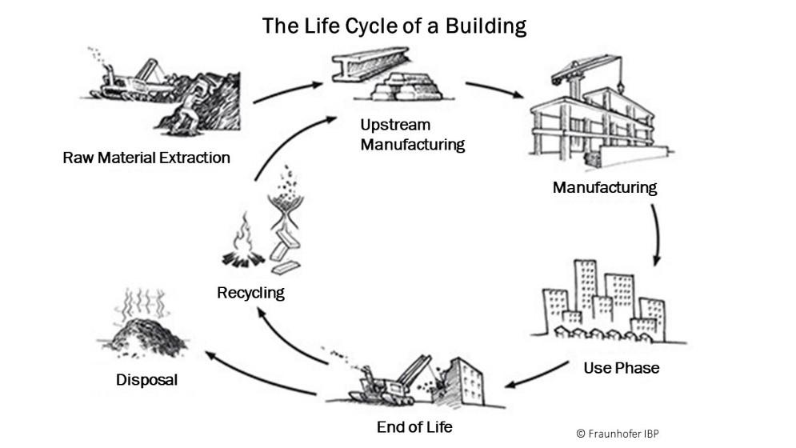

The LCA methodology as it relates to the building industry can be pictured as operating at one of four levels: material, product, building, or industry.

**At the material and product level,** architects and engineers are likely to be consumers of LCA information, that is, they may use this information to guide in their material and product selection process. LCA is calculated as a collection of materials, which are assembled into a final (or intermediate) product. A quantity take off of the product is completed, and the emissions from each component of the products are summed. To complete a product LCA, a thorough knowledge of the source and quantities of materials and the manufacturing processes of the finished product are required.

**At the building level**, they may themselves be the LCA practitioners, using building specific LCA tools to create LCAs that characterize the environmental footprint of proposed projects, either for the purpose of meeting regulatory requirements (e.g., to stay below a specified impact threshold) or as part of an iterative design methodology that seeks to minimize the environmental impact of a project. Building LCA, or whole-building LCA is a product LCA where the product is the building. In this case, the engineers can be the LCA expert, as the architect understands how the building is constructed, how building materials and products flow to the jobsite, and how the building is going to be operated over time.

**At the industry** level are more likely to be of use to policy makers and planners. LCA method has been used in the building industry to quantify the impacts of cement and steel production, suburban sprawl and urban densification, and changes in land use.

**Case Example of use of LCA in Buildings:** Consider the following example of building considered in Switzerland and the use of LCA to identify the environmental impact of various materials used for the construction of the house. The case represents 3 variants of material and energy use for the building. The LCA thus enables the designer/ architect/ engineers to choose the best resources/ materials for the construction of the building which reduces the impact to the environment caused by these materials and their associated manufacturing process.

